Installing pymango:





Worked:

Verify Installation:



Installing pandas:

pip install pandas

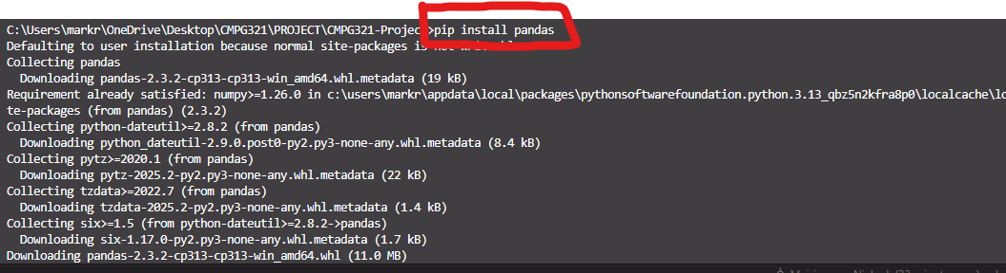

Installing pip openpyxl:

Ensure MongoDB connection:

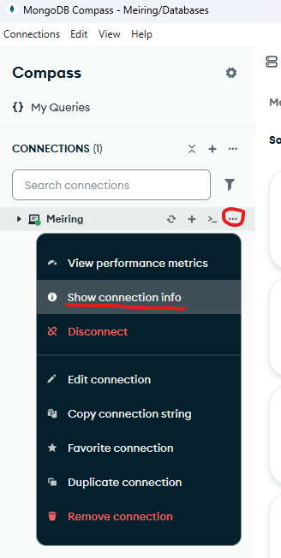

Warn Mark:

Payment_Lines sheet:  


So I changed it to add depositDate as part of the _id to make it unique.

New example:

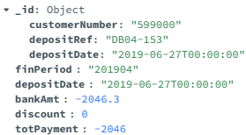

Payment_Header sheet:  




paymentHeaders

Suitability:  Helps with payment tracking, even though it is redundant with paymentLines, having redundancy with anything relating to payments is not potentially bad to have.

So I changed it to add customerNumber as part of the _id to make it unique.

New example:

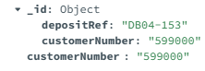

Kafka setup (OLD)

Download java: [Download Java](https://www.java.com/en/download/)

Download: [Apache Kafka](https://kafka.apache.org/downloads)  
NB!!! Specifically this version:

Then download:

[Java Archive Downloads - Java SE 8 | Oracle Africa Region](https://www.oracle.com/africa/java/technologies/javase/javase8-archive-downloads.html)  


setx JAVA_HOME "C:\Program Files\Java\jdk1.8.0_202"

RESTART THE TERMINAL THEN:



echo %JAVA_HOME%

This is kafka folder in downloads:

  
Move the Kafka folder after you have extracted it to your C: drive and rename to just:



Now in Git Bash

To start Zookeeper:



bin/zookeeper-server-start.sh config/zookeeper.properties

THEN IN ANOTHER TERMINAL:

Start Kafka Broker:

bin/kafka-server-start.sh config/server.properties

THEN IN ANOTHER TERMINAL:

Kafka setup (New):

Download Oracle Java JDK 17:

[Java Archive Downloads - Java SE 17.0.13 and later](https://www.oracle.com/java/technologies/javase/jdk17-0-13-later-archive-downloads.html)



In Command prompt

setx JAVA_HOME "C:\Program Files\Java\jdk-17"

setx PATH "%PATH%;%JAVA_HOME%\bin"

RESTART TERMINAL

Make sure this returns this in command prompt:

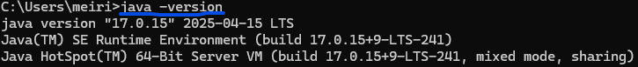



Install Kafka:

[Apache Kafka](https://kafka.apache.org/downloads)

Now in downloads folder:



Extract file and place in C: drive and rename to:



Open the kafka-4.1 folder in Git Bash and run commands:

Setup the broker to respond (YOUR uuid will be different):

1. export KAFKA_LOG4J_OPTS="-Dlog4j.configurationFile=file:///C:/kafka-4.1/config/tools-log4j2.yaml"
2. bin/kafka-storage.sh random-uuid
3. bin/kafka-storage.sh format -t Rj-EMVfyRtaaYKQElD8jvA -c C:/kafka-4.1/config/server.properties --standalone
4. bin/kafka-server-start.sh config/server.properties

While this is running open another git bash terminal:

Test to see if broker is listening:

* Blue: initialise terminal variable to be the same as previous terminal’s
* Red: broker is live and listening
* Green: Create message
* Red (again): broker listens for “testTopic” on port 9092 and returns it.

SUCCESS!!!

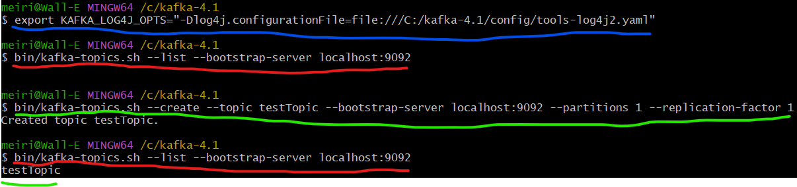

1. export KAFKA_LOG4J_OPTS="-Dlog4j.configurationFile=file:///C:/kafka-4.1/config/tools-log4j2.yaml"
2. bin/kafka-topics.sh --create --topic testTopic --bootstrap-server localhost:9092 --partitions 1 --replication-factor 1
3. bin/kafka-topics.sh --list --bootstrap-server localhost:9092